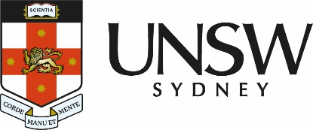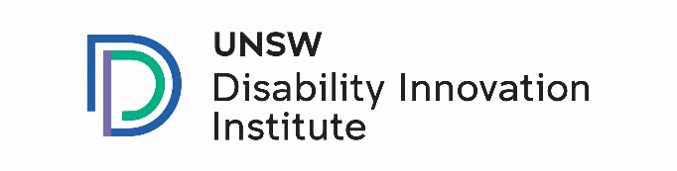

Knowing more about and giving more resources to groups who make information accessible in Australia

This is a summary report or a paper with the most important information we learned from the project

Original report by:

Ariella Meltzer*, Emma Barnes* and Ayah Wehbe**

*Centre for Social Impact, UNSW

**Silent Signs

Partner organisation: IDEAS Disability Information

Easy Read report by:

VALID

# Disability logosIntroduction

People with disability need good accessible information. Accessible means easy to understand.

We know that after COVID-19, the bushfires and floods in Australia, accessible information:

* 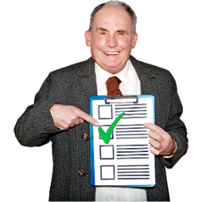is important
* takes time
* 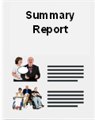takes work to do well.

This summary report is about:

* groups who make information accessible
* 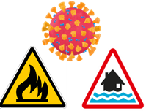what they did during
* COVID-19
* 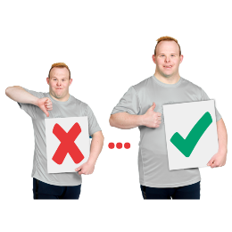the bushfires
* the floods
* what we learnt to make things better.

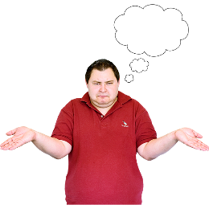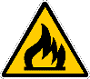

In thissummary report, when we talk about bad things like floods or bushfires, we will call this a **disaster event**.

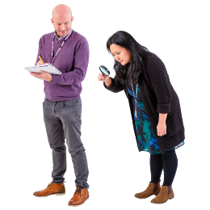**Research questions**

Research means a careful look at something to learn more about it.

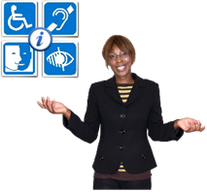We asked accessible information groups:

a) What does it mean to make good accessible information?

b) What was it like making accessible information during COVID-19 and disaster events?

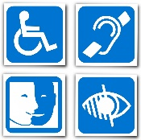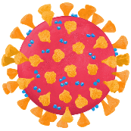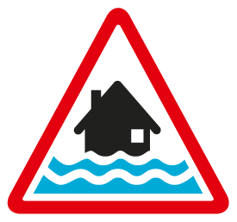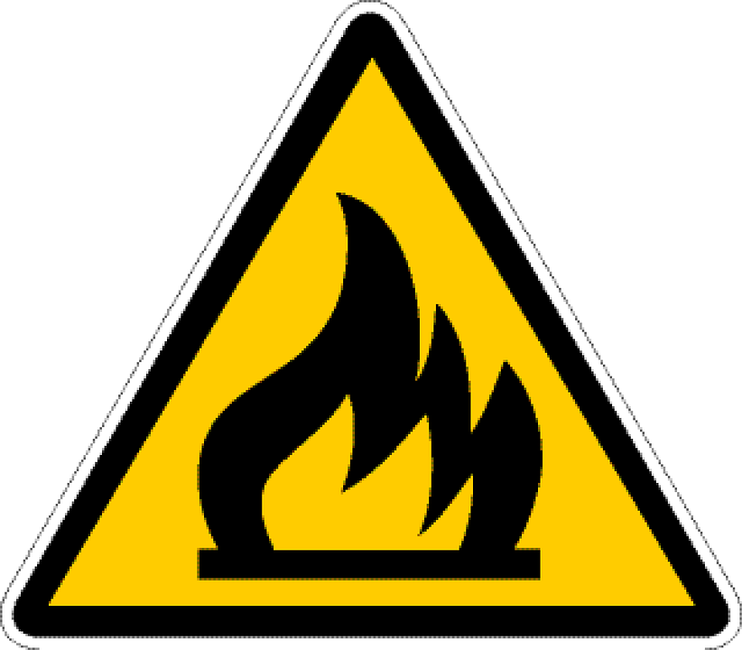

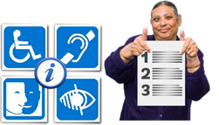c) What helps or stops accessible information now?

d) What things need to change in Australia to make sure people with disability get good accessible information?

## Research PeopleWho we spoke to and how we did it

We spoke to 17 accessible information groups.

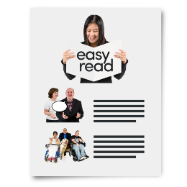The groups we spoke to make accessible information like:

* Easy Read
* Easy English

Words……

* 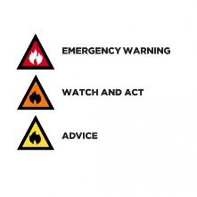Captioning
* 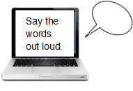Symbols for AAC
* Screen readers
* 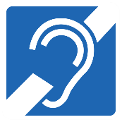Hearing loops
* 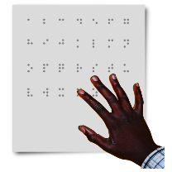Audio formats
* 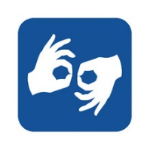Braille
* Auslan

# Disability symbols and information signWhat is accessible information?

The accessible information groups told us 5 important things that say if information is accessible:

1. 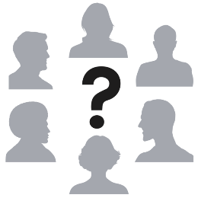**Who is the accessible information for?**

* information is for 1 group of people
* it is important not to think or say that the same types of accessible information are used for everyone.

1. 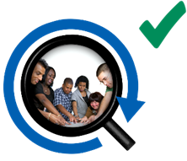**How is the accessible information made?**

* the information is written in ways that work well
* people who need accessible information help to make it and test it.

1. 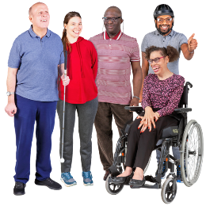**How is the accessible information found?**

* the information is easy to find and get to people who need it
* 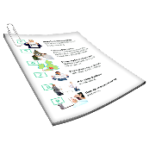information is given out in the way people need it, like a hard copy. Hard copy means information printed on paper

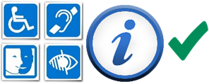

* giving people accessible information in the right way is part of making it accessible.

1. 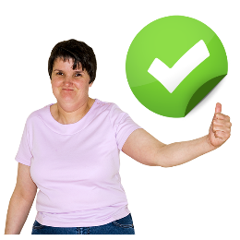**How is the accessible information used?**

* accessible information is made in ways that are helpful
* 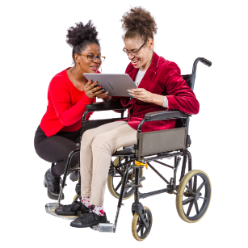some people use accessible information:
* by themselves
* with help from support.
* 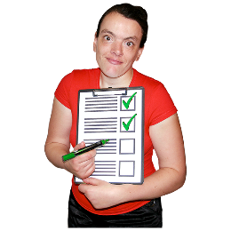information is used to:
* find out news
* learn new things and talk about them.

1. **A blue and white circle with a green check mark and a letter i

   Description automatically generatedWhen can the accessible information be trusted?**

* accessible information can be trusted when:
* 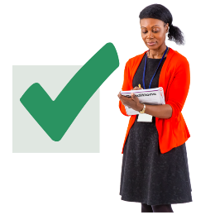it is kept up to date and checked to make sure it says the right things
* made by people or groups that know how to make it
* 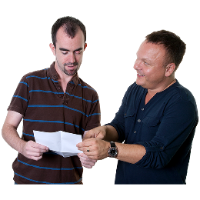it says what people need to know
* people are given accessible information in a way that is friendly and kind, like when people know each other.

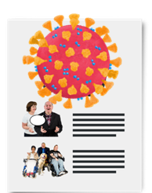**Accessible information about COVID-19**

The groups who made accessible information for COVID-19 told us what happened when they made it. They talked about what they did during 2020 and 2021.

The most important things they said were:

1. **It was hard to tell people all the things that needed to be said about COVID-19 because there were so many things to say.**

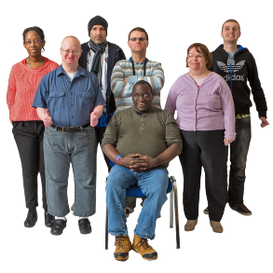Groups who make accessible information knew:

* lots of people needed accessible information
* 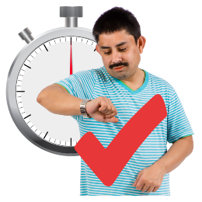more accessible information needed to be made
* accessible information needed to be made quickly.

Some of the things that happened that made their job hard were:

* 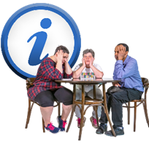information about being safe changed a lot
* getting the right information was hard
* some people with disability did not have support to use the usual accessible information, so new types of accessible information were needed.

1. **It was hard to decide what information to use and how to say it.**

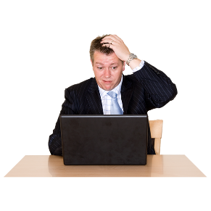Groups who make accessible information knew:

* they had to say the right things. Lots of the time it was hard to know which information to use, like:
* what words to use
* what information people wanted to know
* 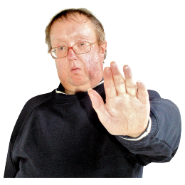what medical information to use.
* it was a big responsibility to share accessible information because a lot of people did not trust information about COVID-19.

1. **A person holding a cash register

   Description automatically generatedIt was hard to do all the work, because:**

* A group of people sitting in chairs holding a sign of dollar sign

  some groups did not get more money or funding to do the COVID-19 work
* 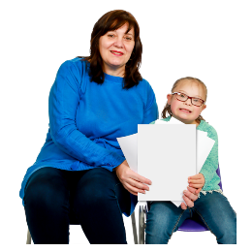some groups got a little bit of extra money or funding but it was not the amount they needed to do the work
* some of the staff were not able to do their work because they were sick or homeschooling. Homeschooling means

to teach a child at home instead of them going to school.

1. **A group of people sitting in chairs with a stopwatch

   Description automatically generatedOther groups did not help enough.**

Groups who make accessible information said:

* A person with his hands up and an information symbol and question mark

  other groups like government groups took a long time to make and give out accessible information
* some information was hard to find or did not say everything it needed to
* groups who could help did not always want to.

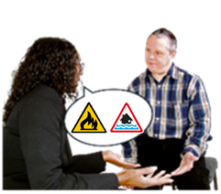**Accessible information in the bushfires and floods**

Groups who make accessible information only said a little bit about making accessible information in disaster events like bushfires and floods.

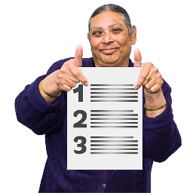The most important things they spoke about were:

1. 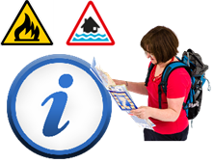**Making accessible information about getting ready for disaster events.**

Lots of groups who make accessible information told us about making information to help people with disability get ready for disaster events.

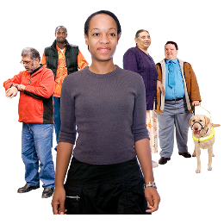The groups did not tell us much about making information when the disaster event was already happening.

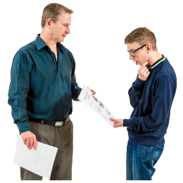This might be because:

* A person pointing at his watch with a red cross

  the most important information needed to be given out right away.
* there was not time for groups to make the information accessible.

1. 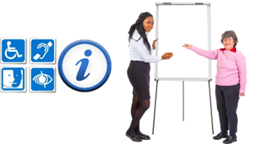**Giving help to emergency services and news media**.

Some groups who make accessible information helped emergency services and news media learn more about how to make information accessible.

A stack of books and a phone with news and information

News media are groups like television, radio and newspapers who share information with the community.

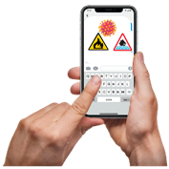The groups who make accessible information helped them learn:

* plain English words to use in emergency text messages.
* A person in a blue suit on a television

  Description automatically generatedwhat information should be read out on screen, like the TV, to make it accessible for people who are blind.

1. **Things that are missing when making accessible information for disaster events**.

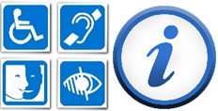Groups who make accessible information told us that accessible information was missing from services used when there is a disaster event, like:

* A sign on the front of a building

  Description automatically generatedevacuation centres – a building that is in a safe place for people to go to in a disaster event
* 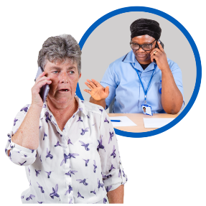recovery services – help to fix buildings or support people who have been part of a disaster event
* entitlements - things like money that people can get help with after a disaster event.

# ListRecommendations or what we think should be changed or made better

The recommendations say what things will help people who use accessible information and the groups who make it.

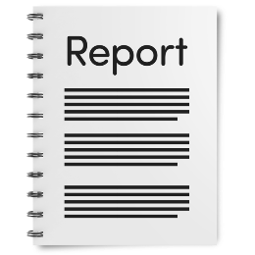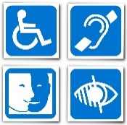This is to help make sure there is more accessible information for people when disaster events happen.

The recommendations in this report say some of the same things about accessible information as the Disability Royal Commission report.

## Recommendation 1:

## A laws and a rules book with a tick Make clearer laws for accessible information

* make clearer laws for accessible information
* 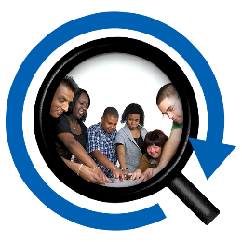make rules about how to follow the laws, like:
* working with people who need to use accessible information and have it checked by people who will use it.
* make sure the information is about what people with disability need to know, like:

health in the community

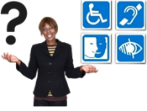disaster events and how people need to keep safe.

* 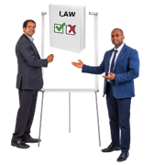do a project that will find out what accessible information people with disability use in the community now and how they use it
* have training for people about the new laws.

## Recommendation 2:

## Information signGive money and help to the groups who make accessible information

* have a way to let the accessible information groups know what information needs to be made accessible
* help groups to have more staff to do the work when a disaster event happens
* let everyone know how much it costs to make accessible information.

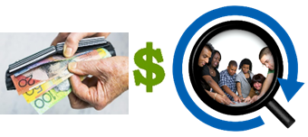This should also say:

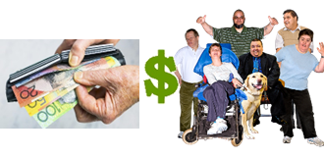how much it will cost to pay people who use accessible information to check it is accessible

* have more groups and businesses who get paid to make accessible information.

## Recommendation 3:

## A rue book with an information symbolSay how Easy Read and Easy English accessible information needs to be made

* 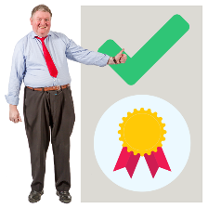 make rules that tell people how Easy Read and Easy English information needs to be made

the Government should say the rules are okay.

* A person sitting at a desk with a computer
  making picturesaccessible informationmake new pictures that groups who make Easy Read and Easy English information can use

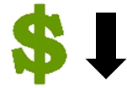The pictures should:

* + 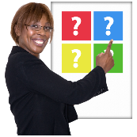not cost too much money to use
  + be able to be changed
  + have Aboriginal and Torres Strait Islander communities in them

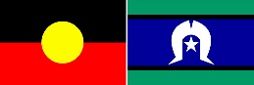

* + look like they are from Australia.
* 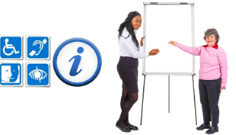look at ways for more groups to:
  + 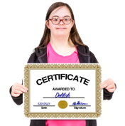learn how to make Easy Read and Easy English information
  + get a certificate to say they know how to make Easy Read and Easy English information.

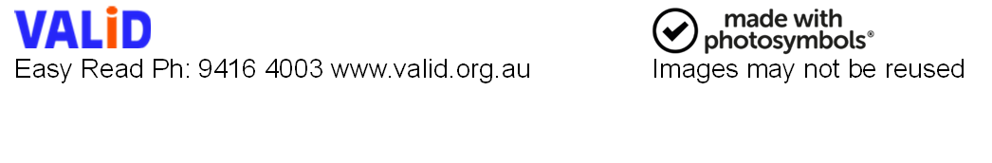

© European Easy-to-Read Logo: Inclusion Europe.

More information at [www.inclusion-europe.eu/easy-to-read](http://www.inclusion-europe.eu/easy-to-read)